**CREATE NODE-RED SERVICE**

Date 3 November 2022

Team ID PNT2022TMID37462

Project Name Industrial Specific Fire Alarm System

**AIM:**

To create a web application, create a Node-RED service.

**STEPS TO BE FOLLOWED:**

**STEP 1:** Navigated to the App creation page.

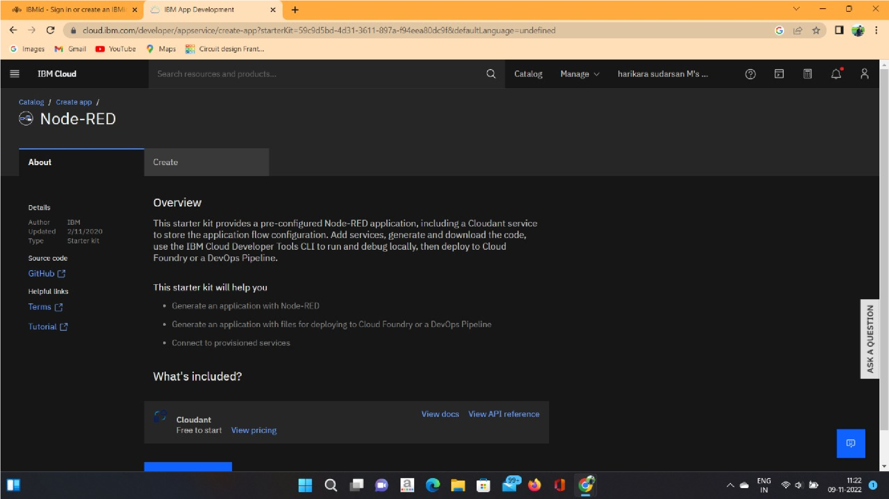

**STEP 2:** Entered project details and click on create

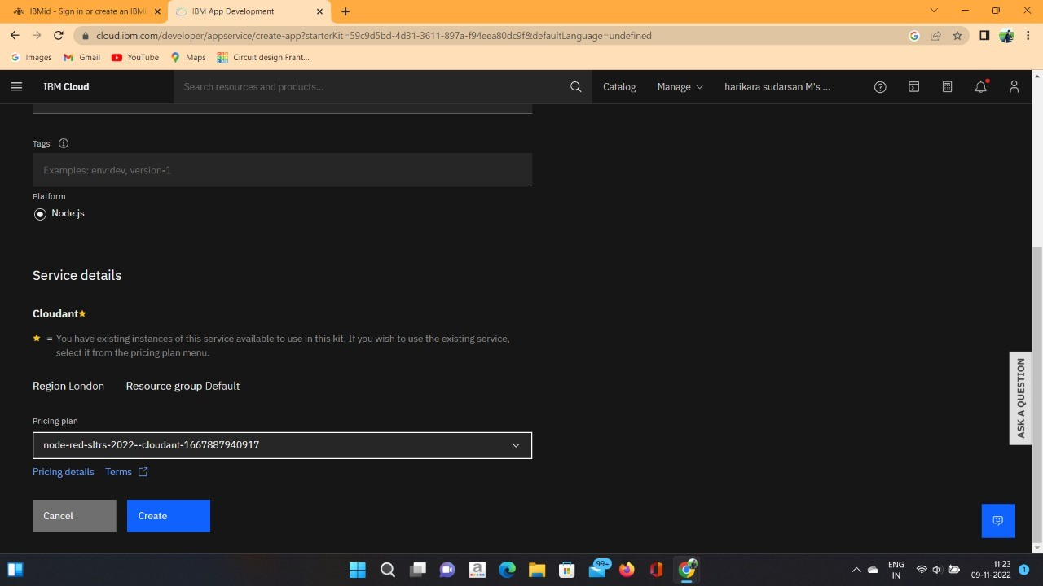

**STEP 3:** Click on the “Deploy your app” button.

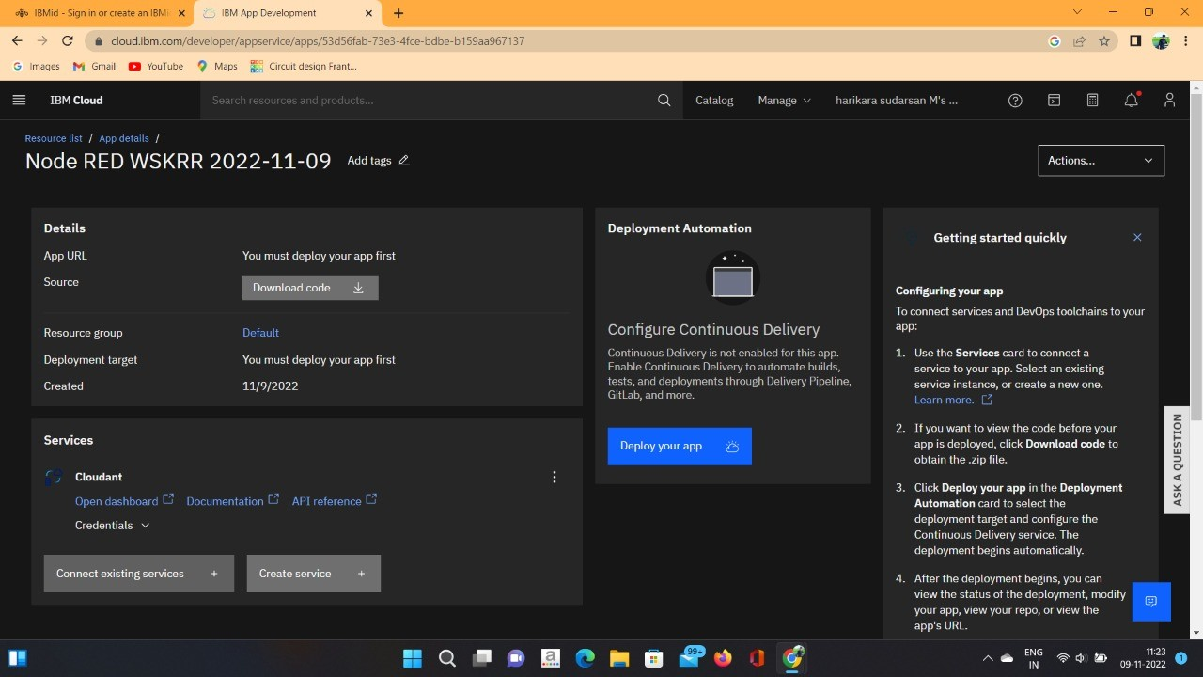

**STEP 4:** Setting up the environment and deploying the app.

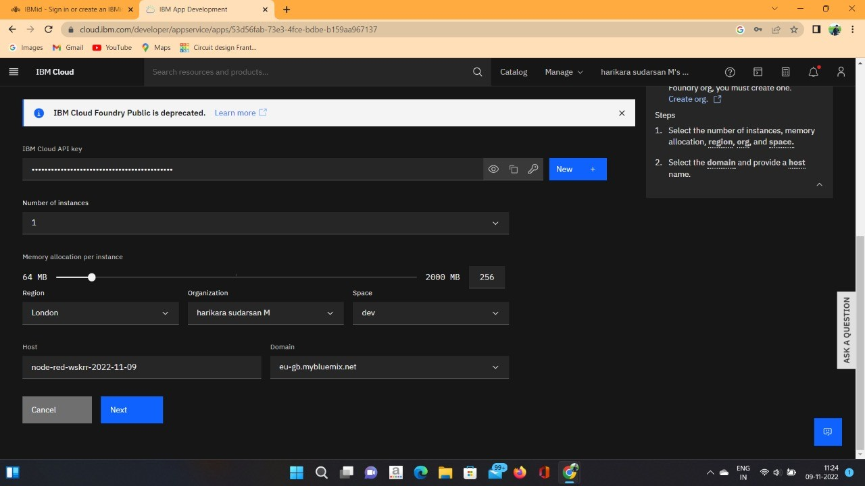

**STEP 5:** The app is deployed.



**RESULT:**  Successfully created a Node-RED service on IBM cloud.